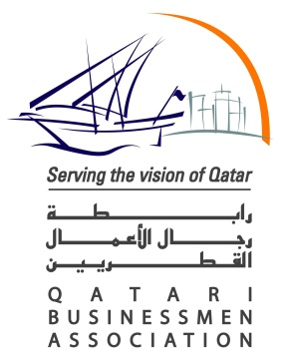 |  | 
 |  | 

ITALIAN BUSINESS MISSION TO QATAR

Focus Infrastructure

DOHA, March 19-22, 2012

WORKING LANGUAGE: ENGLISH

Monday, March 19

20.00 Welcome cocktail at the presence of Vice Minister Ciaccia
[Four Seasons Hotel - Al Daibel room, 2nd floor]

Tuesday, March 20

09.30-10.00 Registration of participants
[Four Seasons Hotel]

10.00-11.00 Opening session
[Four Seasons Hotel – Al Daibel room, 2nd floor]

10.00 Opening Address
Mario Ciaccia, Vice Minister for Infrastructures and Transports
Sheikh Nawaf Bin Nasser Al Thani, Board Member QBA

10.30 Introductory remarks
Cesare Trevisani, Deputy President Confindustria
Video on Italian Infrastructure Sector
Giandomenico Ghella, President International Contractors ANCE
Massimo D’Aiuto, CEO Simest

11.00 Signing agreement between Simest and Concordia Capital

11.10-11.30 Coffee break
[Four Seasons Hotel – Al Daibel Pre-function, 2nd floor]

11.30-14.00 Business Opportunities in Qatar
[Four Seasons Hotel – Al Daibel room, 2nd floor]

11.30-11.55 Andre Went, CEO Qatar Stock Exchange

11.55-12.20 Ahmed Almas, Mwani Qatar

12.20-12.45 Ambrose McGuire, Infrastructure Affairs Adv. Ashghal

      - Frank Harrigan, Dir. Economic Affairs Dept. General Secretariat for the
Development Planning

13.10-13.35 Hamad Al Abdan, Chief Business Operating Officer Enterprise Qatar

13.35-14.00 Geoff Brain Mee, Deputy CEO Qatar Railways Company

At the end of each intervention, there will be a brief Q&A session.

14.00-15.30 Networking lunch
[Four Seasons Hotel – Foyer 2nd floor]

15.30-17.00 Seminar on Financial Strategies for Infrastructures in Qatar
[Four Seasons Hotel – Al Daibel room, 2nd floor]

  - Welcome address:
Massimo D’Aiuto, CEO Simest

15.45 Keynote speeches:
Philippe Jouard, CEO Concordia Capital
George Nasra, General Manager International Bank of Qatar

  - Q&A

17.00-18.00 Day one sum-up with the Italian organizers
[Four Seasons Hotel – Al Daibel room, 2nd floor]

20.00 Dinner offered by Concordia Capital
[Four Seasons Hotel – Terrace Restaurant]

Wednesday, March 21

09.00-12.30 Presentation of Qatari Diar and Lusail Real Estate Development Co. and visit to Lusail City
[Lusail City]

13.30 – 15.00 Lunch offered by International Bank of Qatar

[Four Seasons Hotel]

Authorised by the QFC Regulatory Authority License 00129

